Software Requirements Specification

for

KAIte
Version 1.8 approved
Prepared by,
Team BlackBox
COS420Fall2026
11/08/2026
Table of Contents
1. Introduction 1
1.1 Purpose 1
1.2 Document Conventions 1
1.3 Intended Audience and Reading Suggestions 1
1.4 Product Scope 1
1.5 References 1
2. Overall Description 2
2.1 Product Perspective 2
2.2 Product Functions 2
2.3 User Classes and Characteristics 3
2.4 Operating Environment 3
2.5 Design and Implementation Constraints 3
2.6 User Documentation 4
2.7 Assumptions and Dependencies 4
3. External Interface Requirements 4
3.1 User Interfaces 4
3.2 Software Interfaces 17
3.3 Communications Interfaces 17
4. System Features 17
4.3 Conversation Analysis & Reflection 18
4.4 Error-detection Testing 18
4.5 User Points System 19
5. Other Nonfunctional Requirements 20
5.1 Performance Requirements 20
5.2 Safety Requirements 20
5.3 Security Requirements 20
5.4 Software Quality Attributes 21
5.5 Business Rules 21
6. Other Requirements 21

Revision History
Name | Date | Reason For Changes | Version
Initial Version | 10/02/26 | Initial Document Creation | 0.0.1
Content Addition | 10/05/26 | Reflection Conversion, Initial Requirements | 0.0.2
Content Addition | 10/06/26 | Requirements added | 0.0.3
Minor Revision | 10/07/26 | Revised Requirements | 0.0.4
Minor Revision | 10/08/26 | Revised Requirements | 0.0.5
Content Addition | 10/11/26 | Initial User Interfaces | 0.0.6
Content Addition | 10/15/26 | Revision History added, Updated multiple sections | 0.0.7
Minor Revision | 10/16/26 | Revised Requirements | 0.0.8
Minor Revision | 10/18/26 | Revised Requirements | 0.0.9
Minor Revision | 10/21/26 | Revised Requirements, Requirements added | 0.1.0
Major Revision | 10/22/26 | Revised Requirements, Updated multiple sections | 0.1.1
Major Revision | 10/23/26 | Updated multiple sections | 0.1.2
Minor Revision | 10/24/26 | Revised multiple sections | 0.1.3
Minor Revision | 10/25/26 | Revised multiple sections | 0.1.4
Minor Revision | 11/01/26 | Revised Requirements | 0.1.5
Minor Revision | 11/03/26 | Revised Requirements | 0.1.6
Minor Revision | 11/4/26 | Revised Requirements | 0.1.7
Content Addition | 11/6/26 | Added User Interfaces | 0.1.8

This page intentionally left blank.

Introduction

Purpose
KAIte v1.8 is an application extension built off of the WeFlect AI reflection application with an optional testing playground for improving users’ agentic error-detection skills and history tracking progress over time through a user account integrated with the University of Maine’s internal communication platform, CollaborAITE. Further details are provided in the Product Description document.

The purpose of this SRS is to define the architecture, UI, functional and non-functional requirements, and other related intricacies of the KAIte application system. The scope of this product covers the software architecture in Section 1.4.

Document Conventions
This Document was created based on the IEEE template for System Requirement
Specification Documents. Requirement prioritization is assigned individually and is not inherited by higher-level requirements.

Intended Audience and Reading Suggestions
This document is for developers, project managers, users, and testers. The rest of the SRS contains the vital information for the requirements of the KAIte application. It is recommended to refer to Section 1.5 for reference material and Appendix A: Glossary for a short list of glossary terms as this document is read through.

Product Scope
For the architecture design of KAIte, the Model-View-Controller (MVC) is used to separate the user interface, application logic, and data. React and TypeScript are used for the front-end, Node.js and Express.js for the back-end, and Firebase for authentication and data storage. This architecture improves security, performance, and maintainability while integrating Claude AI to support reflection and practice sessions. Further details are provided in the Software Architecture design document (in Section 1.5).

References
- IEEE Computer Society, IEEE Std 830-1988: IEEE Recommended Practice for System Requirement Specification Documents, 1988.
- Team BlackBox, F26-TeamB, GitHub, 2026. [Online]. Available: https://github.com/COS420-F25/F26-TeamB
- [redacted], Project Description, Google Docs, 2026. [Online]. Available: [redacted]
- [redacted], [External] Agent Task Flow Diagram, Miro, 2026. [Online]. Available: [redacted]
- [redacted], [Lo-fi] wireframe/mockup, Figma, 2026. [Online]. Available: [redacted]
- [redacted], [Hi-fi] wireframe/mockup, Figma, 2026. [Online]. Available: [redacted]
- [redacted], and McCollum, S., Software Architecture, Google Docs, 2026. [Online]. Available: [redacted]
- [redacted], UC Diagram(s), LucidChart, 2026. [Online]. Available: [redacted]
- [redacted], Use Case Description, Google Docs, 2026. [Online]. Available: [redacted]

Overall Description

Product Perspective
KAIte is meant for teaching users to better understand their relationship with generative AI by developing their ability to detect errors in AI-generated output. This is accomplished through a “practice mode” expansion on the WeFlect reflection conversation, allowing users to receive LLM responses containing intentional errors and track their ability to catch them over time via a stored history on their CollaborAITE account. A user earns points for their progress. The application’s task flow diagram (below) can be better viewed on the [External] Agent Task Flow Diagram in Section 1.5 (or the embedded image link).

Product Functions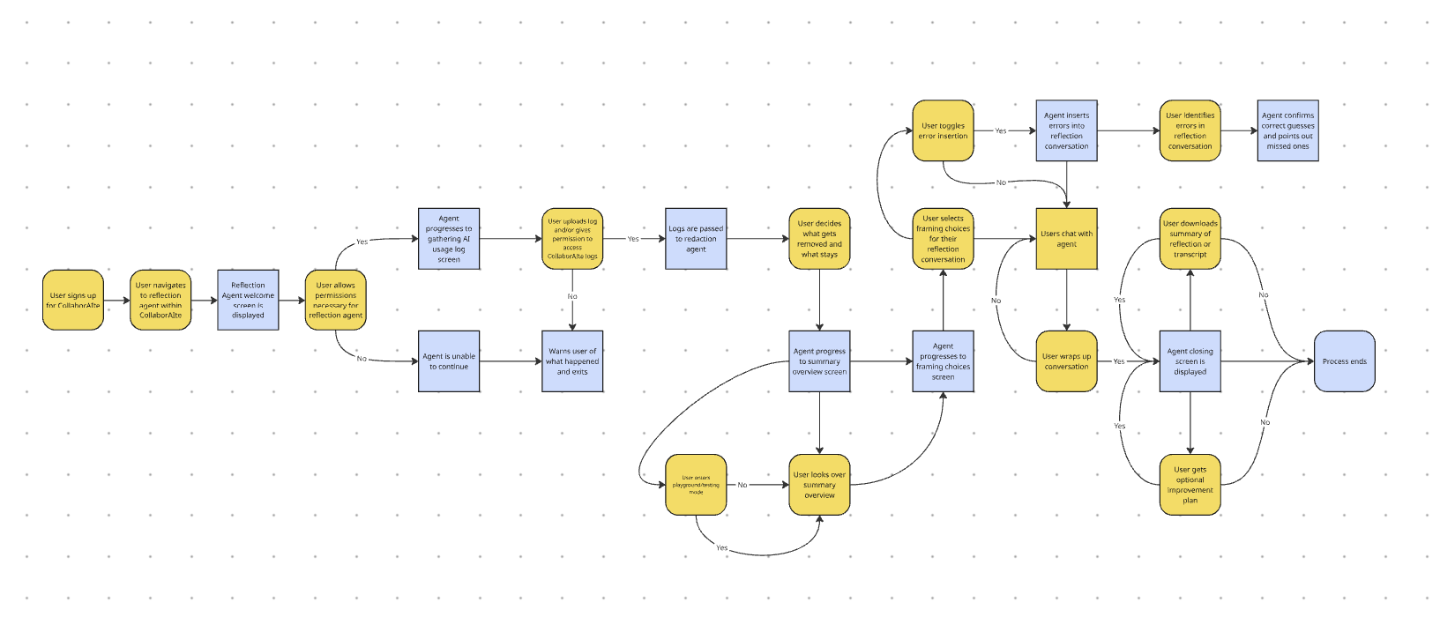
- Account Creation:
  - Input email: Allows the user to input in their email address.
  - Input password: Allows the user to input a password.
  - Login with SSO/Google: Allows the user to log in using an existing Google account.
  - Authorize user: Allows unauthorized users to become authorized users.
- Account History & Tracking Progress:
  - Input login credentials: Allows the user to log in using the credentials they created an account with.
  - Adjust AI settings: Allows users to adjust their settings, such as framing choice, and what the system saves to the account.
  - View reflection summary: Allows the user to view summaries of previous reflection conversations.
  - Input search request: Allow users to search and filter reflection conversation history.
  - View Metrics: Allows users to track overall or specific account metrics progress.
- Conversation Analysis & Reflection:
  - Upload files: Allows users to upload generative AI conversation logs.
  - View AI usage metrics: Allows users to view the system’s calculated AI usage metrics.
  - Converse with an AI agent: Allows the user to engage in a conversation with the AI agent.
  - Input feedback: Allows the user to submit feedback to the AI agent.
- Error-catching Testing:
  - Toggle error-catching mode ON: Allows users to turn on to be tested for error-catching in reflection conversation.
  - View error-catching test results: Allows users to review successfully identified and missed errors.
- User Points System:
  - Earn user points: Allows users to earn points based on goals set and error-detection achievements.
  - View user points: Allows users to view their user points.
  - Collect digital collectibles: Allows the user to exchange user points for redeemable digital collectibles.

User Classes and Characteristics
KAIte is designated for one specific user class, the authorized user, which begins as an unauthorized user. The authorized user would typically be a student of the University of Maine system.

A secondary user class is the reflective AI agent through the WeFlect system that KAIte uses in its operation.

Operating Environment
KAIte was created using the React App, HTML, CSS, and TypeScript. Application usable when HTML is not blocked.

Design and Implementation Constraints
- Technical: Must build KAIte off from WeFlect and integrate both systems into CollaborAITE’s platform.
- Security: Must be able to protect authorized user PII from being shared with external AI agents or their browser(s) and prevent unauthorized access.
- Performance: Must be able to maintain a cohesive conversation with the authorized user.
- Connectivity: Requires internet access.
- Accuracy: Must be able to keep track of intentional errors in agentic output for proper tracking and identification.
- Functionality: Must be able to function across supported web browsers and between the three applications: (1) KAIte, (2) WeFlect, and (3) CollaborAITE.
- Time: The system must be completed within the Fall 2026 semester and project scheduling.
- Data Retention: Must be able to store authorized user’s AI external and internal usage data logs and reflection conversations.
- Programming Standards: Maintain consistent coding practices, scripting, HTML structure, naming conventions and other development standards across WeFlect and CollaborAITE.

User Documentation
TBD.

Assumptions and Dependencies
- Existing Code: Must remain compatible with existing codebases WeFlect and CollaborAITE.
- Developer Knowledges and Experience: Developers will be responsible for coding standards across all systems.
- System Integration: Shared functionality depends on compatible interfaces and data structures between WeFlect and CollaborAITE.

External Interface Requirements

User Interfaces
    - Lo-fi Interfaces
Refer to the reference material in Section 1.5 for the LucidChart links or the embedded image link below.
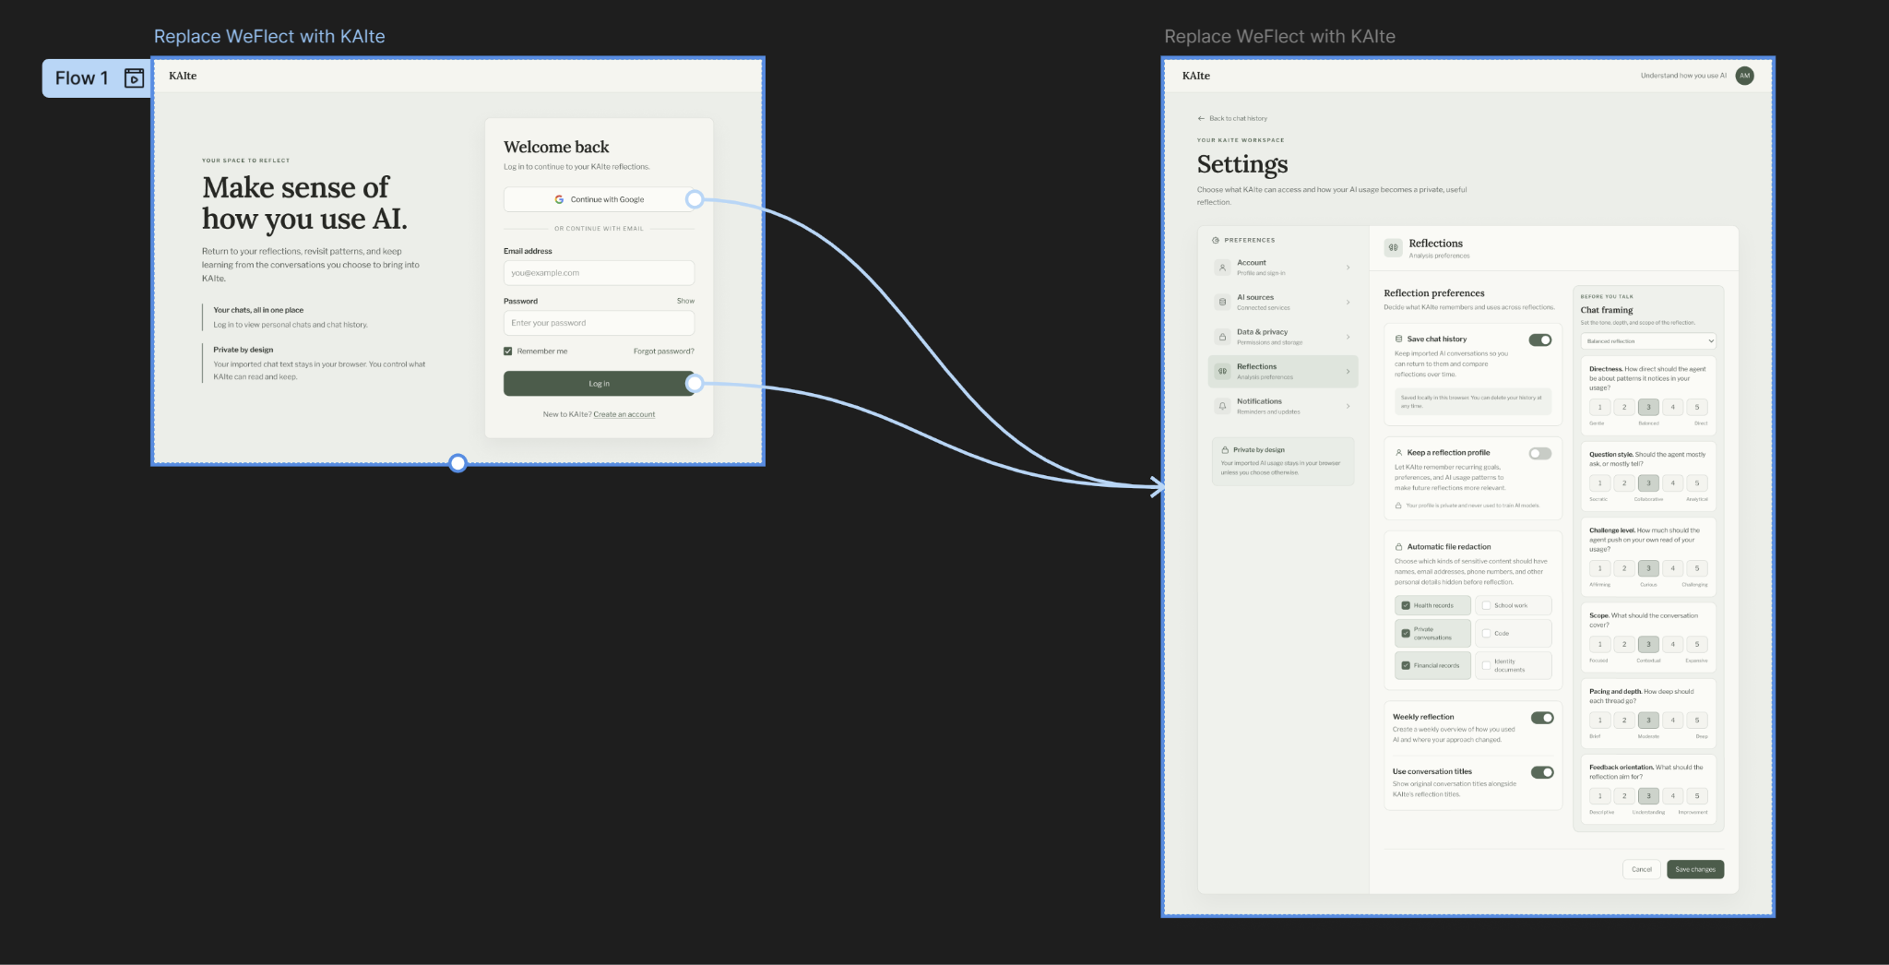

- Login to access settings:
  - Primary purpose: Give users the ability to change settings only when logged in.
  - Fields: Login with gmail, login with email+password.
  - Actions: Login, create account, adjust settings such as framing choice, what KAIte saves.
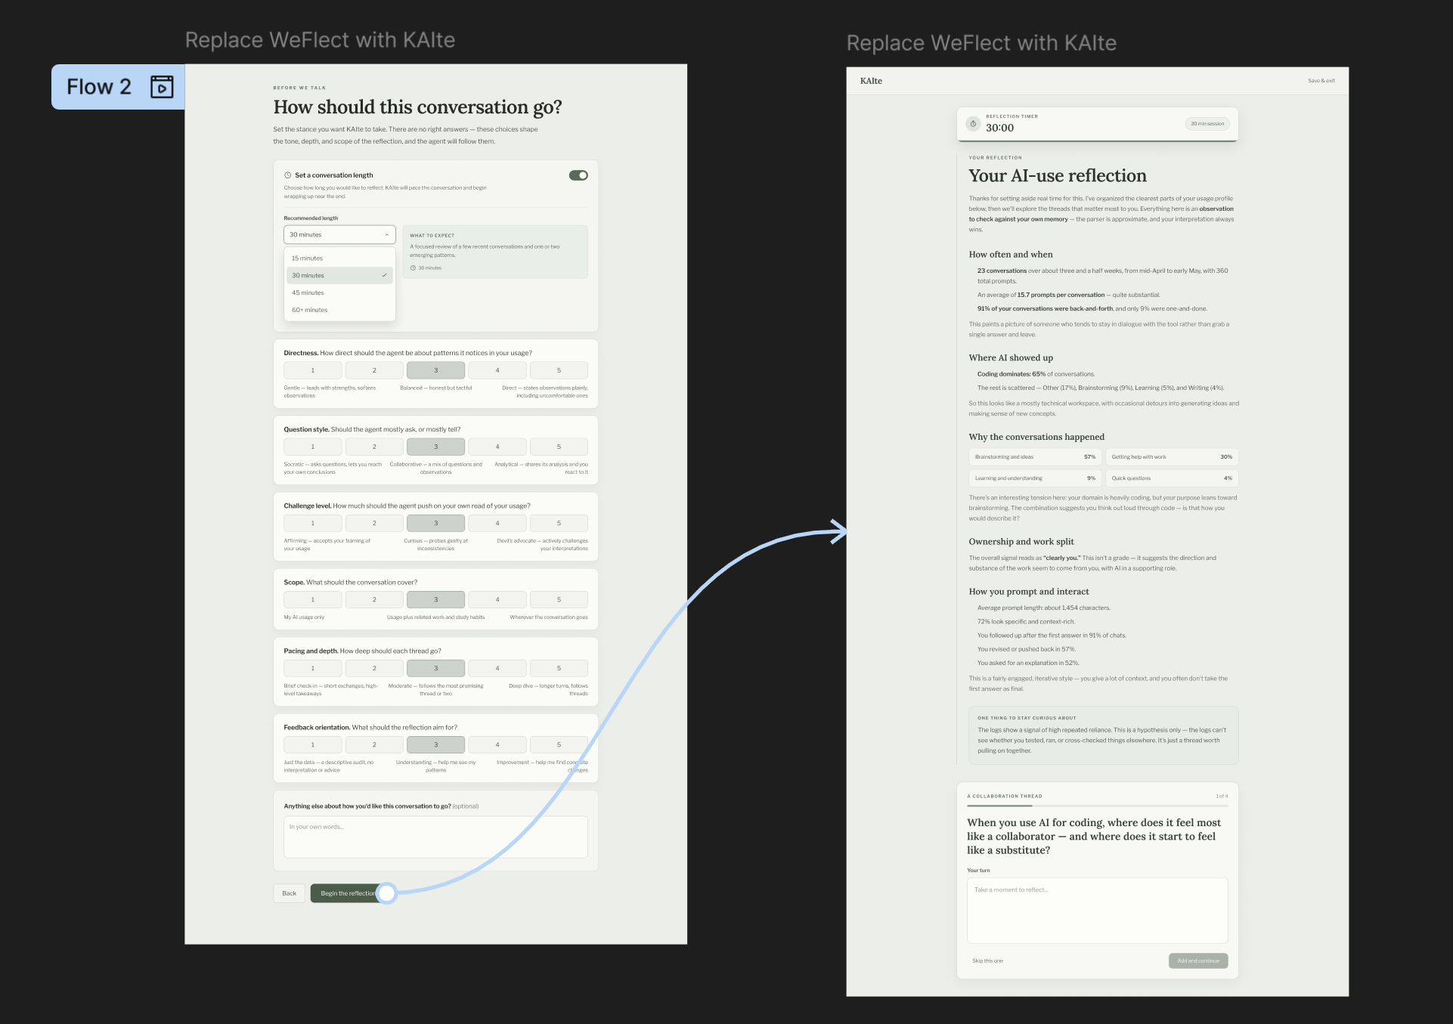

- Ability to set a conversation timer:
  - Primary purpose: allows users to set a time limit for conversation with varying scope.
  - Features: Framing choices, timer length, user input.
  - Actions: Set timer, set framing choices’ scale, reflection conversation.

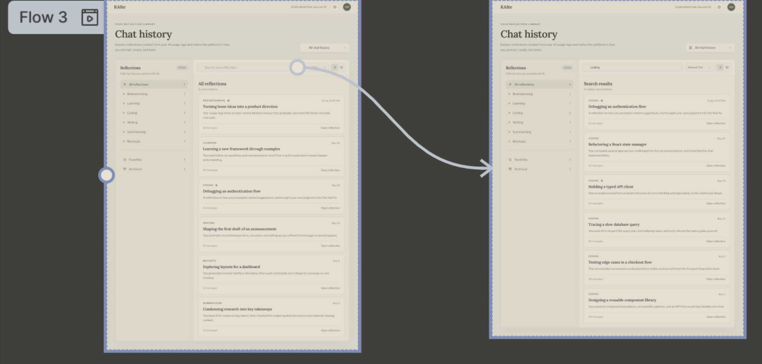

- Search previous conversations:
  - Primary Purpose: Allow users to search and filter reflection conversation history.
  - Features: Conversation search bar, conversation filters, list of saved conversations.
  - Actions: Search conversation history based on keywords, filter conversation history to organize.

    - Hi-fi Interfaces
Refer to the reference material in Section 1.5 for the LucidChart links or the embedded image link below.

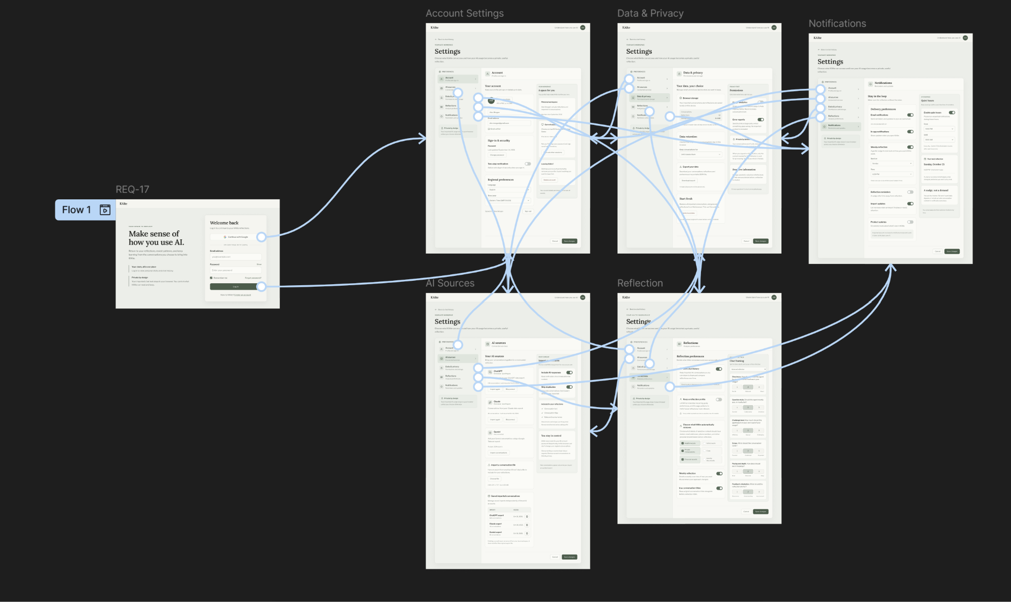

- Login to access settings:
  - Primary purpose: Gives users the ability to change settings only when logged in.
  - Fields: Login with gmail, login with email + password.
  - Actions: Login, create account, adjust settings, access other setting category pages.

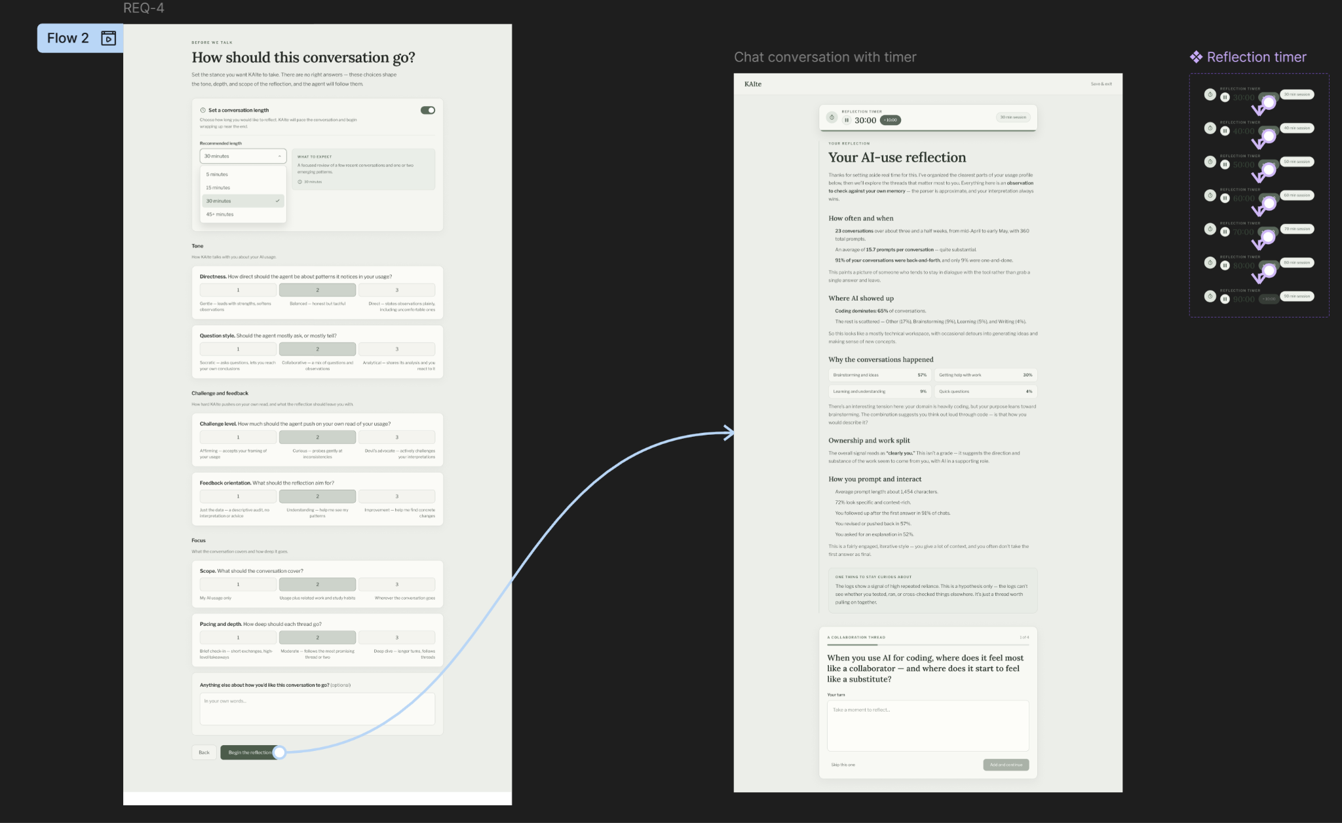

- Ability to set a conversation timer:
  - Primary purpose: Allows users to set a time limit for conversation with varying scope.
  - Features: Framing choices, timer length, user input.
  - Actions: Set timer, set framing choices’ scale, add time to countdown in conversation, pause countdown timer, participate in reflection conversation.

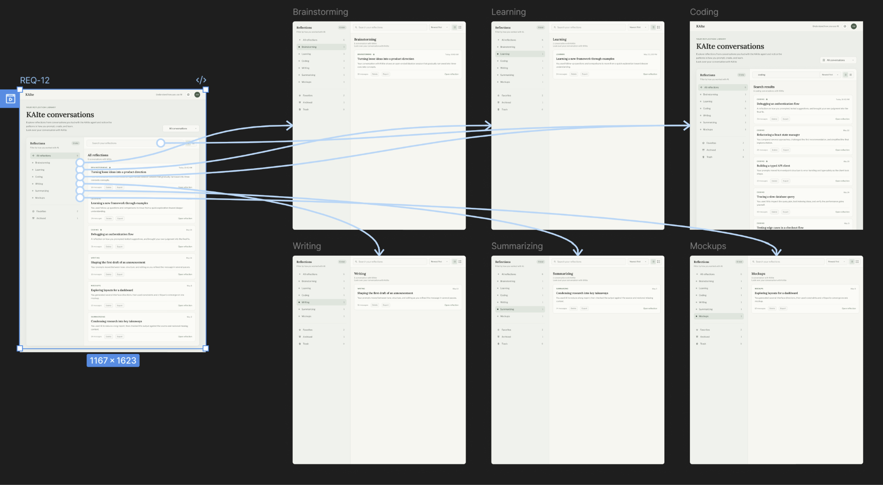

- Search previous conversations:
  - Primary Purpose: Allow users to search and filter reflection conversation history.
  - Features: Conversation search bar, conversation filters, list of saved conversations.
  - Actions: Search conversation history based on keywords, filter conversation history to organize.

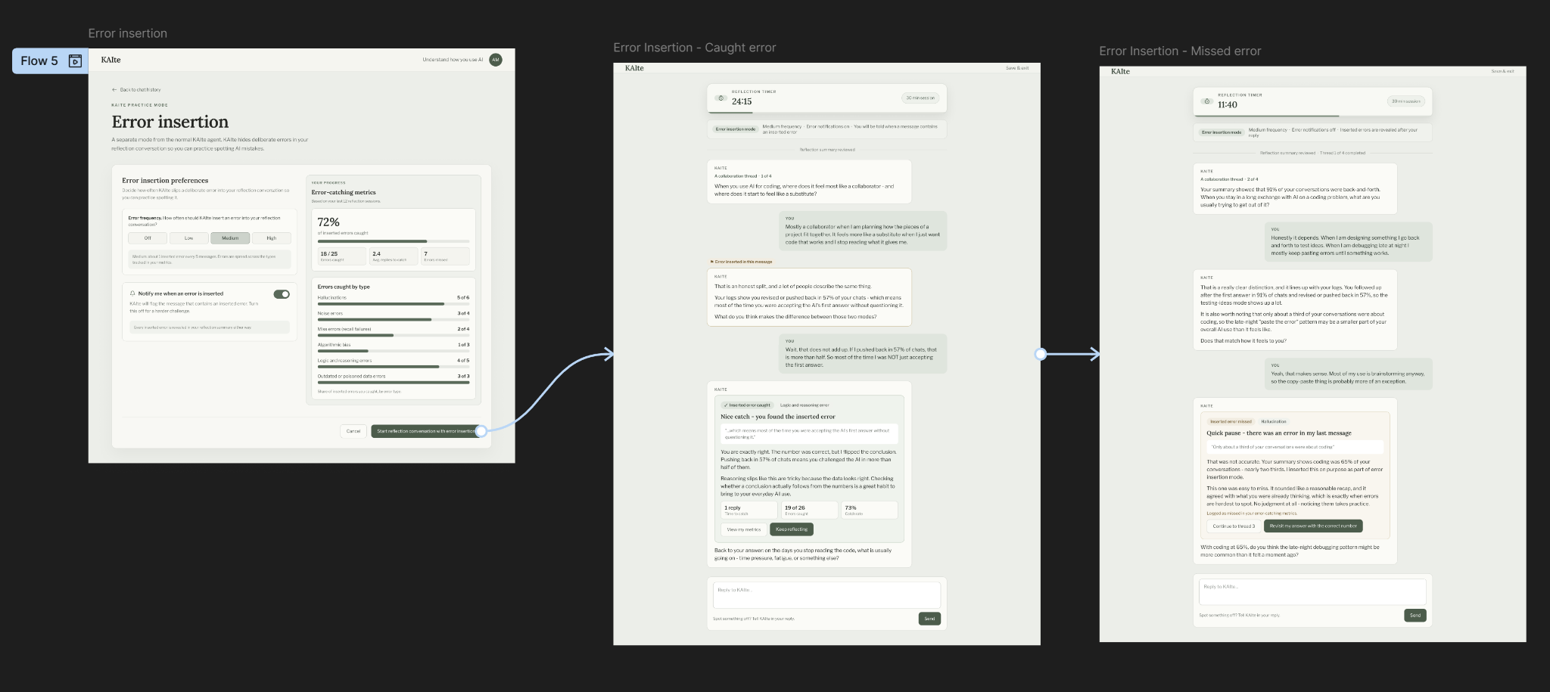

- Error insertion mode:
  - Primary Purpose: Allows users to enter error insertion mode.
  - Features: Error insertion into/settings page, metrics on past conversations error spotting rates, example conversations with correct user guesses, and incorrect user guesses for error spotting.
  - Actions: Begin error insertion mode, choose frequency of errors inserted, toggle error insertion warnings, participate in reflection conversation.

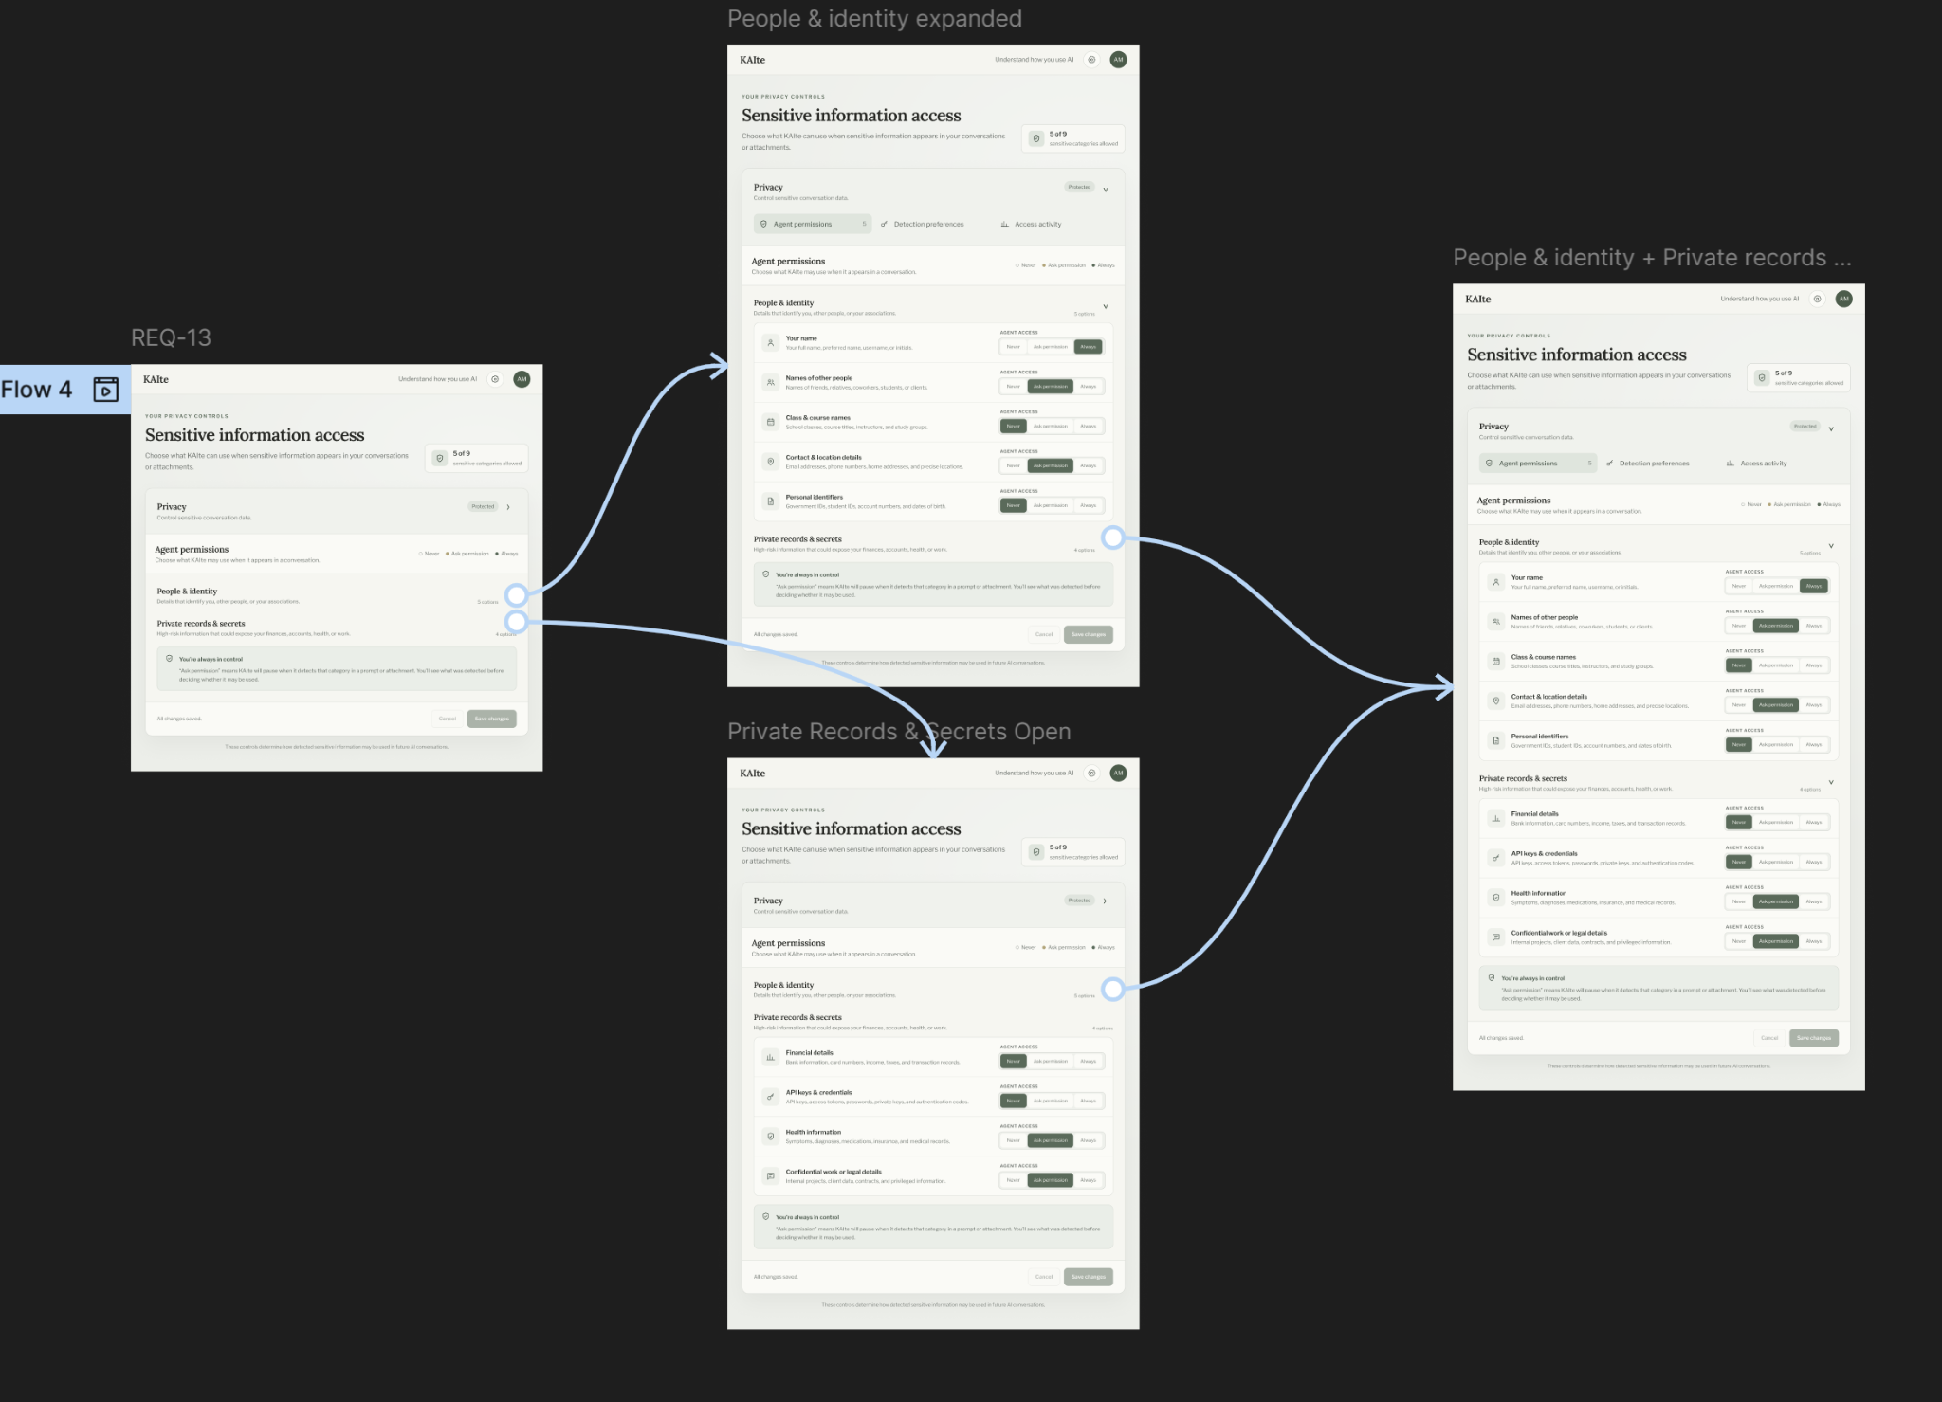

- PII/SI access permissions settings for KAIte:
  - Primary Purpose: Allow users to set what PII/SI information KAIte has access to.
  - Features: Agent permissions, settings for People & Identities, settings for private records.
  - Actions: Set permissions for KAIte.

      - Hi-fi Interfaces Updates
The following is a temporary placement for hi-fi interface updates as to not interfere with the feedback / changelog process above.

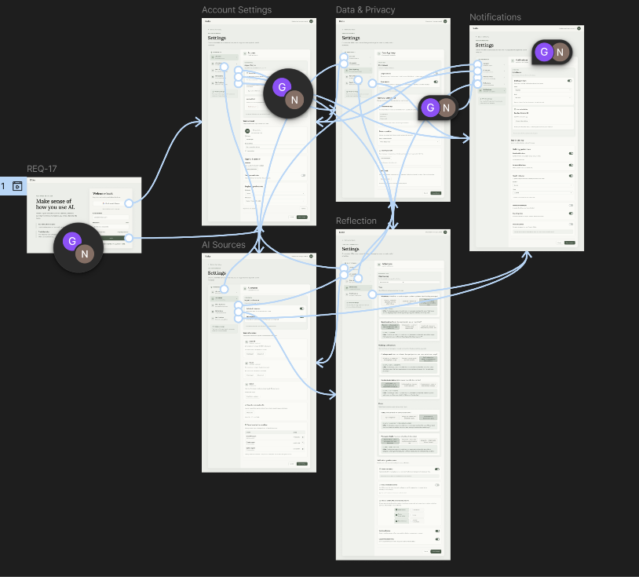

- Login to access settings:
  - Primary purpose: Gives users the ability to change settings only when logged in.
  - Fields: Login with gmail, login with email + password.
  - Actions: Login, create account, adjust settings, access other setting category pages.

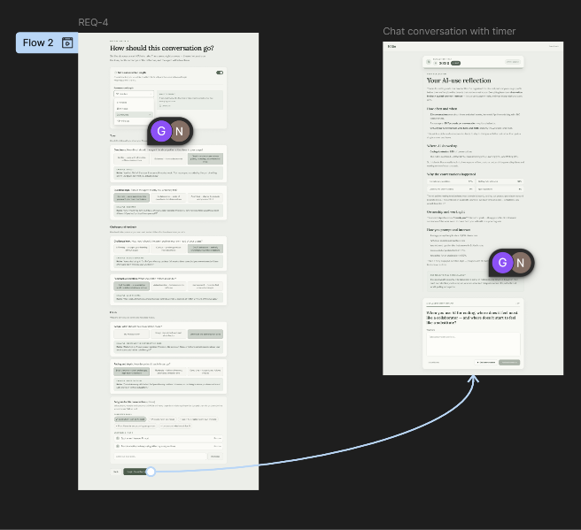

- Ability to set a conversation timer:
  - Primary purpose: Allows users to set a time limit for conversation with varying scope.
  - Features: Framing choices, timer length, user input.
  - Actions: Set timer, set framing choices’ scale, add time to countdown in conversation, pause countdown timer, participate in reflection conversation.

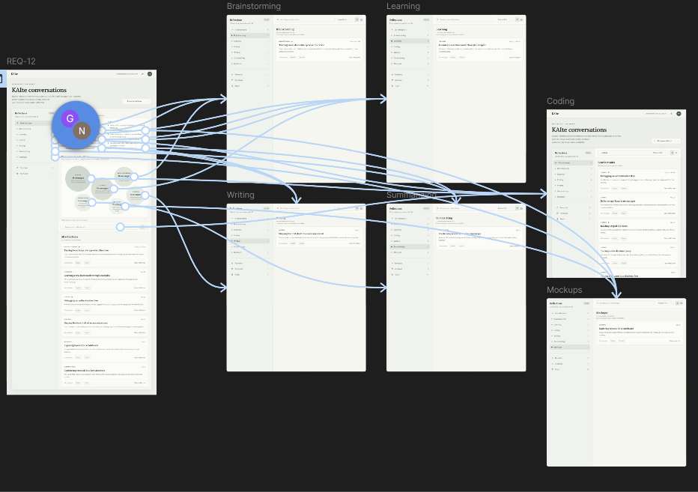

- Search previous conversations:
  - Primary Purpose: Allow users to search and filter reflection conversation history.
  - Features: Conversation search bar, conversation filters, list of saved conversations.
  - Actions: Search conversation history based on keywords, filter conversation history to organize.

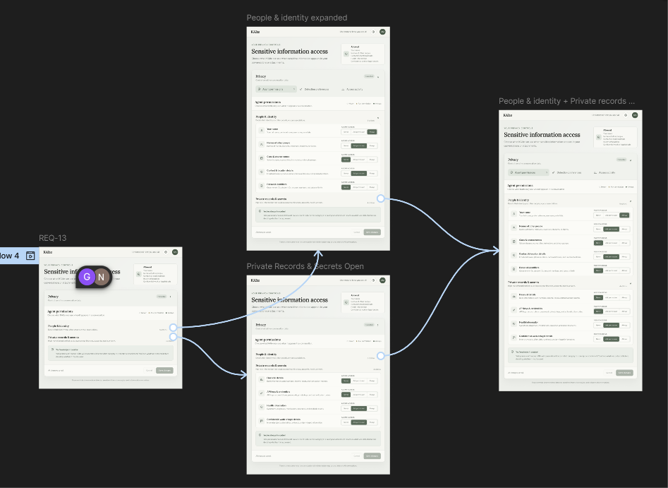

- PII/SI access permissions settings for KAIte:
  - Primary Purpose: Allow users to set what PII/SI information KAIte has access to.
  - Features: Agent permissions, settings for People & Identities, settings for private records.
  - Actions: Set permissions for KAIte.

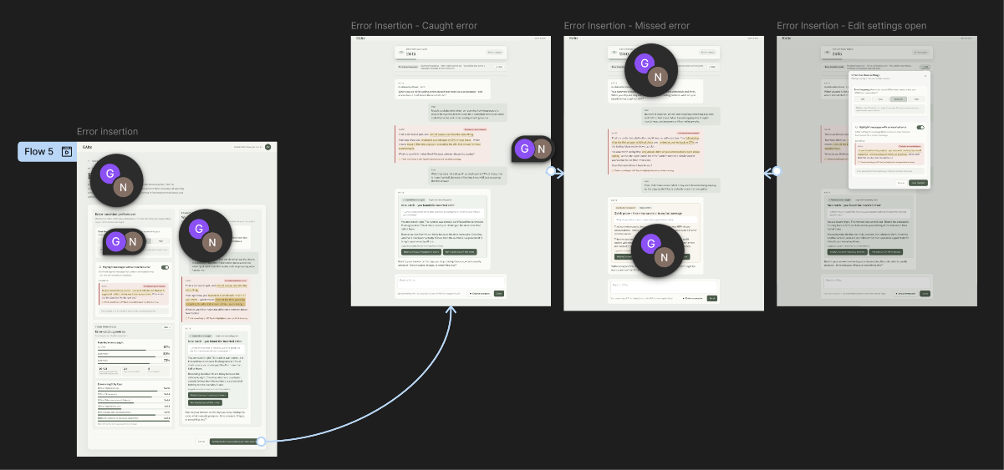

- Error insertion mode:
  - Primary Purpose: Allows users to enter error insertion mode.
  - Features: Error insertion into/settings page, metrics on past conversations error spotting rates, example conversations with correct user guesses, and incorrect user guesses for error spotting.
  - Actions: Begin error insertion mode, choose frequency of errors inserted, toggle error insertion warnings, participate in reflection conversation.

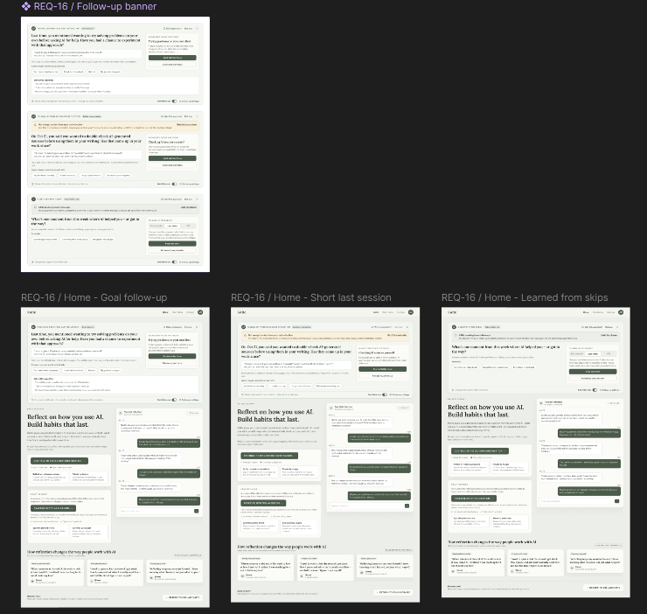

- Follow up questions:
  - Primary Purpose: Allows users to reflect on previous conversations they’ve had and goals they set, without entering a full conversation.
  - Features: Follow up question.
  - Actions: Begin error insertion mode, choose frequency of errors inserted, toggle error insertion warnings, participate in reflection conversation.

Software Interfaces
- Implementation Constraint: All integrated applications (1) KAIte, (2) WeFlect, and (3) CollaborAITE will maintain compatible software interfaces. Any changes to shared interfaces must preserve compatibility between all systems.

Communications Interfaces
- Web Communication: Use HTTPS for secure communications between web browsers and servers.
- Data Transfer: All integrated applications (1) KAIte, (2) WeFlect, and (3) CollaborAITE will use consistent data formats, such as JSON, when exchanging and storing data.
- Security: Sensitive information will be wiped or encrypted using TLS.
- Synchronization: Shared data between all applications must retain consistent updates that reflect one another when users interact with each application’s system: (1) KAIte, (2) WeFlect, and (3) CollaborAITE.

System Features
TBD.

  - Account Creation & Login
Description and Priority

Priority: high.
4.1.2 Stimulus/Response Sequences
An unauthorized user can create an account to become an authorized user by creating an account via two routes: with an email address and password or with an SSO or other provider (i.e. Google account).

- Stimulus: TBD.
- Response: TBD.

- Stimulus: TBD.
- Response: TBD.
4.1.3 Functional Requirements
REQ-17: The system shall allow the user to sign in or register to access their personal chats and saved settings.

  - Account History & Tracking Progress
4.2.1 Description and Priority
This feature allows users to have an account integrated by CollaborAITE’s account system where they can access conversation and interactions with the WeFlect reflection system and view progress tracking.

Priority: high.
4.2.2 Stimulus/Response Sequences
When an authorized user logs into the system, they can manage their AI permissions, upload internal or external AI usage logs, view their usage history, and track progress. When a user chooses to upload AI usage logs, the system opens a file selection dialog, allowing them to select and confirm the files they wish to upload. Once the files are received, the system displays a confirmation message indicating a successful upload. Users can also access detailed summaries of their AI usage for individual sessions or actress their entire history, download conversation reviews, and search through previous reflection sessions. Through the “Summaries” tab, the system displays a list of previously saved conversations with the AI agent, which allow users to select, review, and download individual conversations.

- Stimulus: TBD.
- Response: TBD.

- Stimulus: TBD.
- Response: TBD.
4.2.3 Functional Requirements

Conversation Analysis & Reflection
4.3.1 Description and Priority
In this feature, the system will contain a reflection agent that reads conversation transcripts uploaded by the user from other AI models, analyzes the logs for patterns, and then lead a reflection conversation in which it conducts an interaction with various questions with the user to have them to think in a deeper way about the benefits and drawbacks of how they use generative AI.

Priority: medium.
4.3.2 Stimulus/Response Sequences
- Stimulus: TBD.
- Response: TBD.

- Stimulus: TBD.
- Response: TBD.
4.3.3 Functional Requirements
TBD.

Error-detection Testing
4.4.1 Description and Priority
The feature includes an error-detection testing mode that intentionally introduces errors into WeFlect’s reflection conversations to assess the user’s ability to identify those errors and measure which were correctly detected or overlooked.

Priority: high.

4.4.2 Stimulus/Response Sequences
When the authorized user requests practice responses with errors during the reflection conversation, the agent will introduce intentional errors in a generated response for the user to attempt to identify the errors. Afterward, the system will display the practice response.

The authorized user may view their generative AI error-catching process over time where the system will calculate their error-catching ability filtered by time.

- Stimulus: TBD.
- Response: TBD.

- Stimulus: TBD.
- Response: TBD.

4.4.3 Functional Requirements
TBD.

User Points System
TBD.

4.5.1 Description and Priority
TBD.

Priority: low.

4.5.2 Stimulus/Response Sequences
TBD.

4.5.3 Functional Requirements
TBD.

4.6 Additional System Functions
The following need to be sorted in their appropriate system features.
REQ-01: The system shall allow the user to upload JSON conversation logs from Chat GPT, Gemini, and Claude.
REQ-02: The system shall identify the user’s primary AI usage categories from a list including brainstorming, coding, getting help, and quality-checking.
REQ-03: The system shall have a reflection agent ask the user about what they think the advantages and drawbacks of the AI usage being analyzed are.
REQ-04: The system shall allow the user to customize how long they want the reflection conversation to run before it begins, such as a 15-minute conversation providing a few questions to think about or an hour-long one to identify deeper usage patterns.
REQ-05: The system shall allow the user to customize how accepting the reflection agent is of user responses that fail to answer agent questions.
REQ-06: The system shall allow the user to provide additional instructions to the reflection agent before the conversation starts.
REQ-07: The system shall provide a summary of the conversation’s findings once the user ends the conversation.
REQ-08: The system shall allow the user to download the conversation summaries.
REQ-09: The system shall give the user the option of having prior findings included for consideration in new reflection conversations.
REQ-10: The system shall allow the user to upload pdfs, docx, and json files so the agent can view them during conversation.
REQ-11: The system shall allow the registered user to re-read previous conversations with the reflection agent.
REQ-12: The system shall allow the user to search previous chats with agents by keywords.
REQ-13: The system shall allow the user to set options for what sensitive information the agent can access.
REQ-14: The system shall ask the user guiding questions about the style of conversation from upload logs the user publishes to further curate how the agent will direct the current conversation.
REQ-15: The system shall allow the user to edit previous summaries on generated agent conversations.
REQ-16: The system shall ask the user follow-up questions the next time they use the system after their previous conversation to encourage further reflection.

Other Nonfunctional Requirements

Performance Requirements
NON-REQ-01: The system shall load the main application page within 3 seconds at least 90% of the time.
NON-REQ-2: The system shall display saved AI use history within 3 seconds of the user’s request 99.99% of the time.

Safety Requirements
NON-REQ-03: The system shall label AI-generated content for the user.

Security Requirements
NON-REQ-04: The system shall encrypt stored user info and saved AI chat history.
NON-REQ-05: The system shall not display a user's saved AI chat history to other users.
NON-REQ-06: The system shall display a banner after sign in that allows users on a shared computer to enable automatic logout and data deletion after 15 minutes of inactivity.

Software Quality Attributes
NON-REQ-07: The system shall allow a new user to access main features, including starting a reflection conversation, viewing previous chats, and accessing account settings, from the main page within three clicks.
NON-REQ-08: The system shall require user confirmation before deleting or overwriting saved chat history.
NON-REQ-09: The system shall support the latest versions of Google Chrome, Microsoft Edge, and Firefox, within 30 days of each browser version’s official release.
NON-REQ-10: The system shall display an error message within 3 seconds of determining a user action cannot be completed, 99.99% of the time.

5.5 Business Rules
TBD.

6. Other Requirements
TBD.
Appendix A: Glossary
- Authorized user: A user who has a verified CollaborAITE account, typically a student
- CollaborAITE: University of Maine’s internal communication platform
- KAIte: (pronounced: kīte) Team BlackBox’s application
- SRS: Software Requirements Specification
- Team BlackBox: The Company Name
- UI (User interface): Visual elements as a guide for what users would interact with.
- User: An individual that would interact with the application.
- WeFlect: An AI Use and Collaboration Reflection Agent built in University of Maine’s YESS Lab where users reflect on their AI usage logs.
Appendix B: Analysis Models
- Architecture Design Diagram:

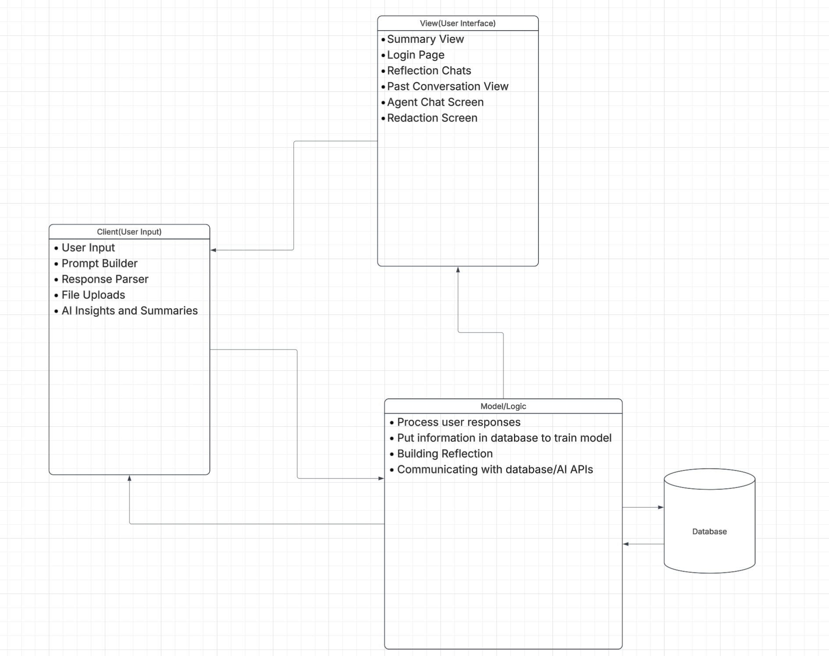
Appendix C: To Be Determined List
TBD.

